Assignment 3

**Exercise #1:**

1. Create two text files in your home directory using **vi** editor.
   1. Run **vi** from command line
   2. Press **i** to start entering the text
   3. Enter the text (a few lines)
   4. Press **Escape** to use **vi** commands
   5. Type **:w** filename and press Enter to save the file.
   6. Type **:wq** and press Enter to leave the editor

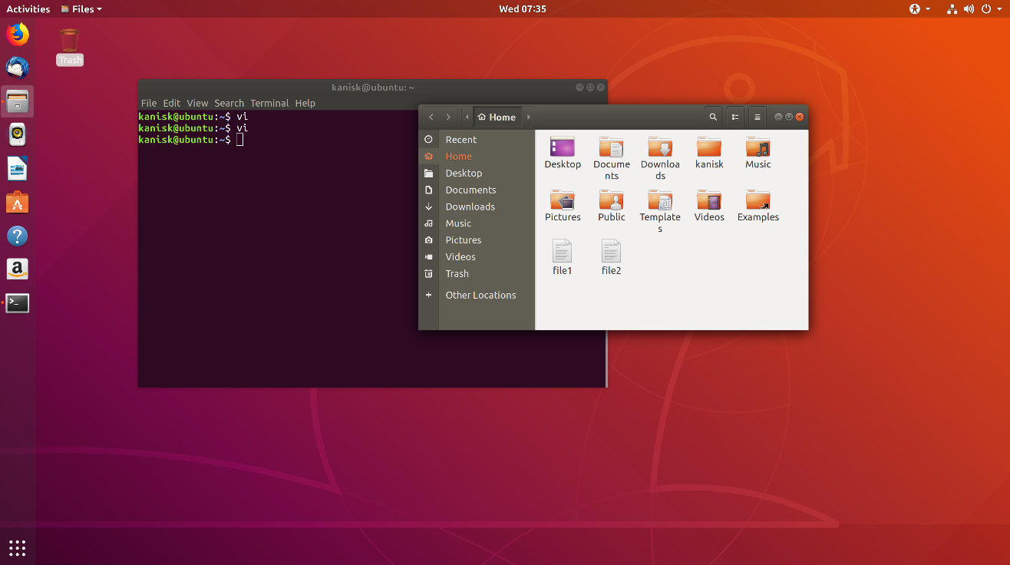

1. Use **ls** command to display complete information about the above files

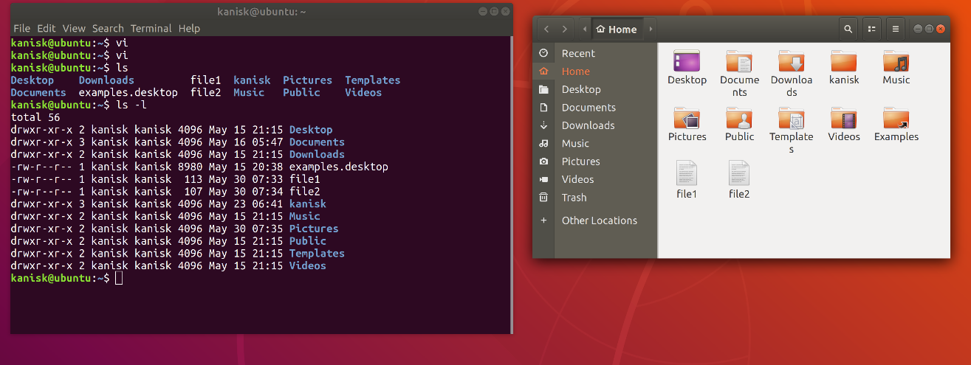

1. Change the permissions for users to: r w – (using u+rw)
2. Change the permission for groups to: r w – (using go+rw)
3. Change the permission for others to: r w – (using o+rw)
4. Use again the *ls* command to display the updated information

**3, 4, 5, 6 together here:**

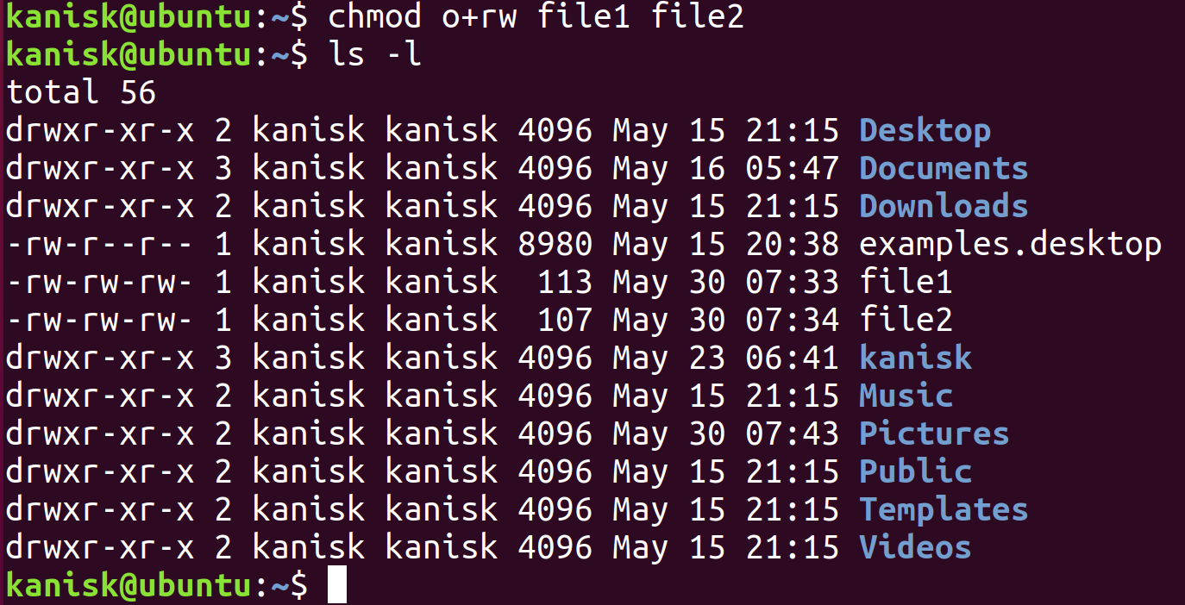

1. List the groups you belong using: *groups username*



**Exercise #2:**

|  |  |  |  |
| --- | --- | --- | --- |
| **Original Perm** | **chmod arguments** | **Final Perm** | **Octal value** |
| r w - r - - - - - | o+rw | r w - r - - r w - | 646 |
| r w - r - - r - - | u-w go-r o-r | r - - - - - - - - | 400 |
| r w x - - - - - - | u+rwx go+rwx o+rwx | r w x r w x r w x | 777 |
| r w x r w - - w x | u-rwx go-rw o-wx | - - - - - - - - - | 000 |
| - - - - - - - - - | u+r go+r o+r | r - - r - - r - - | 444 |
| r - - r - - r - - | -w implies all | r - - r - - r - - | 444 |
| r w - r w - r w - | -w implies all | r - - r - - r - - | 444 |
| r w - r w - r w - | a-w | r - - r - - r - - | 444 |
| - - - - - - - - - | u+w,g+rx,o+x | - w - r - w - - - x | 261 |
| r w x r w x r w x | a=r | r - - r - - r - - | 444 |

**Exercise #3:**

* Create a directory dir-perm in your HOME directory and set permissions to

d r w x - - - - - - Fill in the command chmod _____ dir-perm

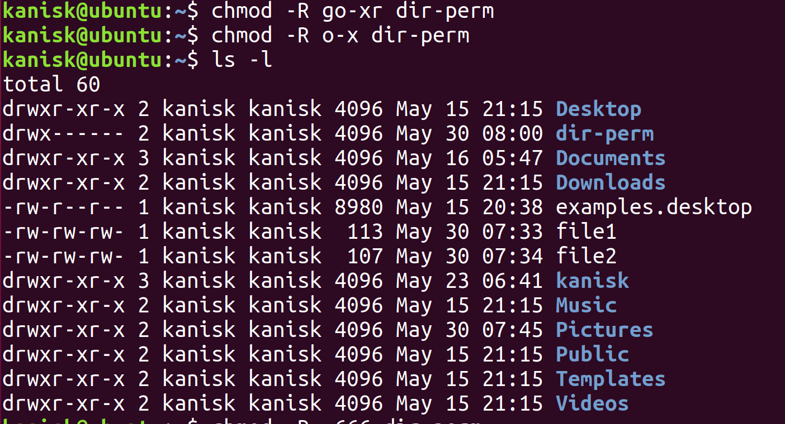

* Make dir-perm the cwd. How ___**cd dir-perm** makes it the current working directory__
* Create a file in the dir-perm directory. How? _________________________

Call it **file-perm**

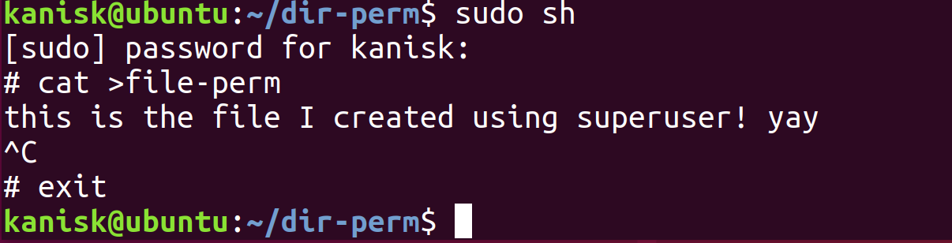

* Perform a “long” listing and give the permissions of the file created above.

Give the permissions. _____________________________

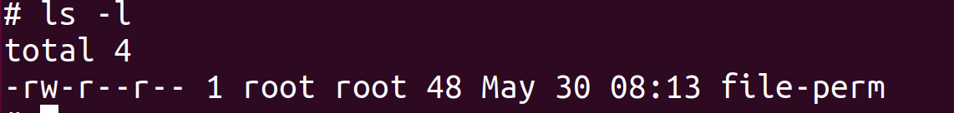

* Move back to the HOME directory. How? _ exit (Ctrl+D from superuser) and

C:\Users\300972577\Desktop\imgs\3-4.png

* Change the permissions to d r - x - - - - - -. How chmod __________

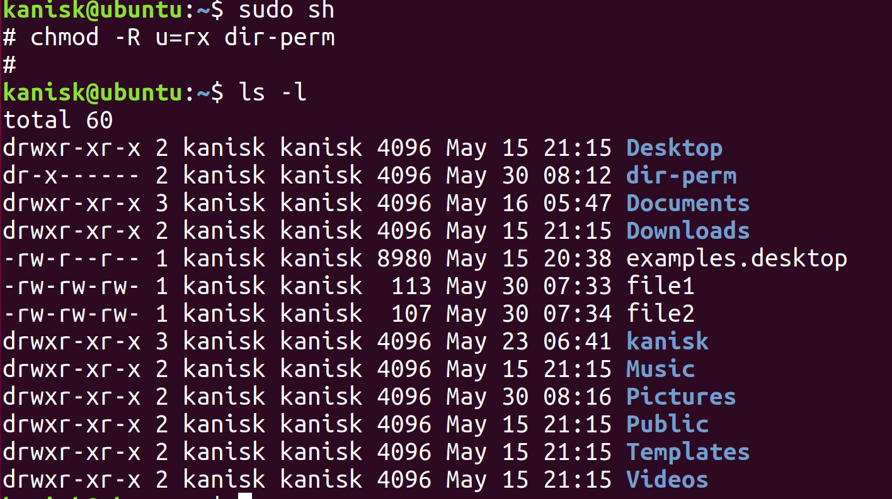

* Move to the dir-perm directory. How ___**cd dir-perm**___
* Create a second file in the directory (Use an editor) and try to save the file.

What happened?

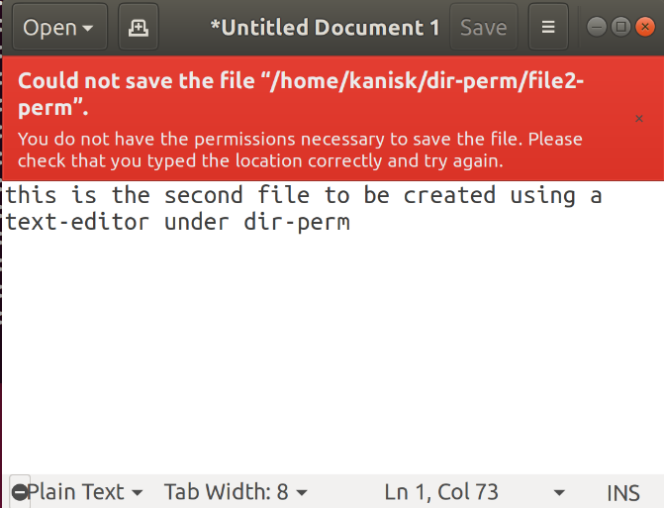

* Now edit the file-perm using an editor and save it.

What happened?

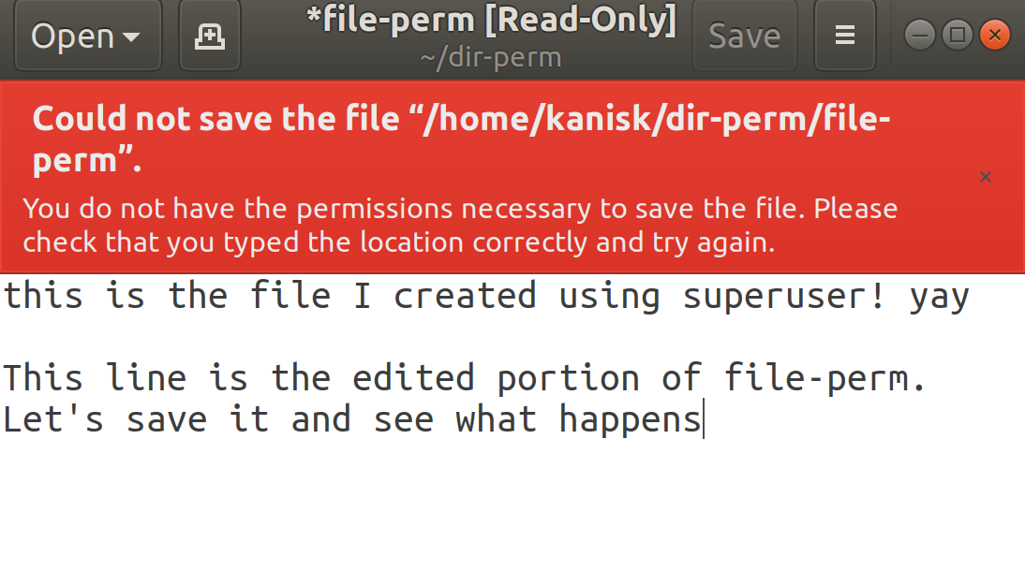

* Change the permissions so members of your group can access the dir-perm

directory, list the contents of the directory and read the file-perm file. Give the commands (steps) used here.

Steps

1. Switch to HOME directory using cd ..
2. Get into super user using sudo sh
3. Use chmod -R go+r dir-perm. This should set the directory, and its contents permissions to read only. Then exit superuser using Ctrl+D or exit
4. Now members of group can access dir-perm, list the contents, and read the file-perm file, but they can’t manipulate anything as seen below

